Objectives:

* Task 1: Provision the lab environment
* Task 2: Configure local and global virtual network peering
* Task 3: Test intersite connectivity

Architecture diagram:

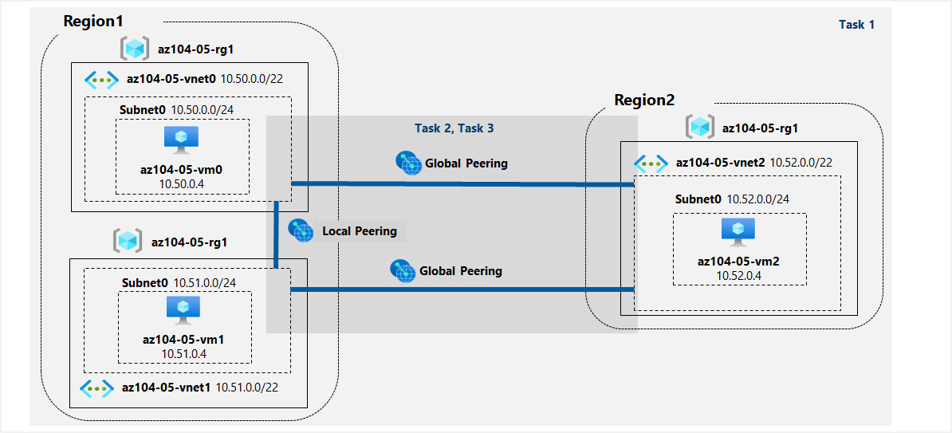

Task 1: Provision the lab environment:

In this task, we will deploy three virtual machines, each into a separate virtual network, with two of them in the same Azure region and the third one in another Azure region.

After we have uploaded the required files in the Cloud Shell pane, we run the following commands to create a resource group that will be hosting the lab environment. The first two virtual networks and a pair of virtual machines will be deployed in the first region (location1). The third virtual network and the third virtual machine will be deployed in the same resource group but another region (location2).

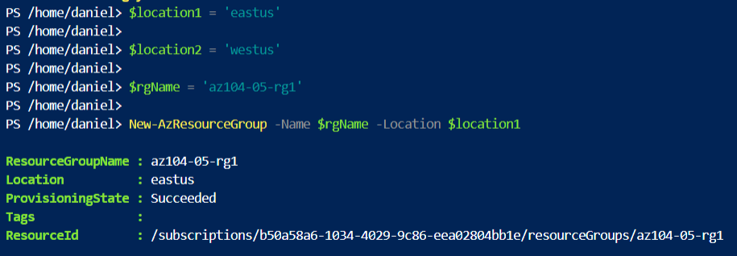

From the Cloud Shell pane again, we run the following commands to create the three virtual networks and deploy virtual machines into them by using the template and parameter files we uploaded earlier:

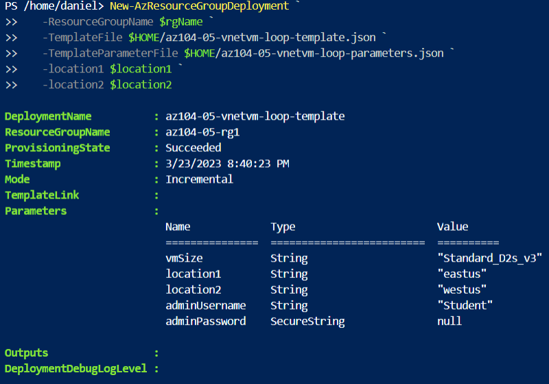

Task 2: Configure local and global virtual network peering:

Here, we will configure local and global peering between the virtual networks, deployed in the previous tasks.

First, we verify that the first two are located in the same Azure region and the third one in a different Azure region.

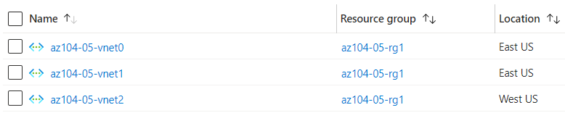

For the different peering here, I ran the different PowerShell commands from the Cloud Shell since the portal was not displaying the virtual networks from the previous task. The result is the same and we can see the peering being successful:

Here we can see both peering for virtual network **vnet0** - one from **az104-05-vnet0** to **az104-05-vnet1** and the other from **az104-05-vnet1** to **az104-05-vnet0.**

And the second peering - from **az104-05-vnet0** to **az104-05-vnet2** and the other from **az104-05-vnet2** to **az104-05-vnet0.**

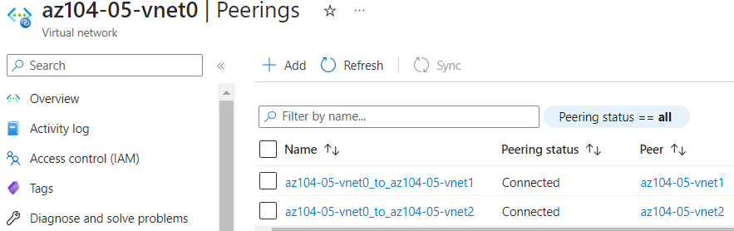

The final peering is between the following two - one from **az104-05-vnet1** to **az104-05-vnet2** and the other from **az104-05-vnet2** to **az104-05-vnet1.**

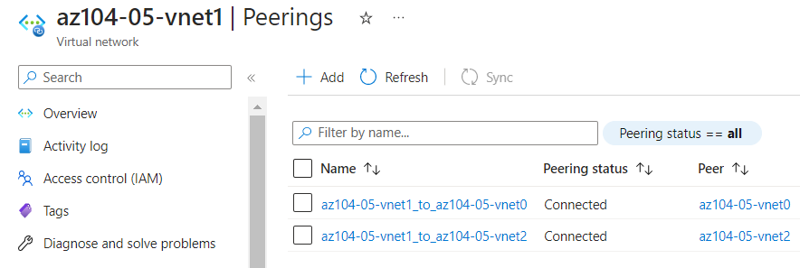

Task 3: Test intersite connectivity:

In this task, we will test connectivity between virtual machines on the three virtual networks that we connected via local and global peering in the previous task.

To begin with, we have to login in the **az104-05-vm0 virtual machine by pressing on Connect -> RDP -> Connect with RDP and we download the RDP file. For logging in, we use Student as a username and the updated password from the parameters file:**

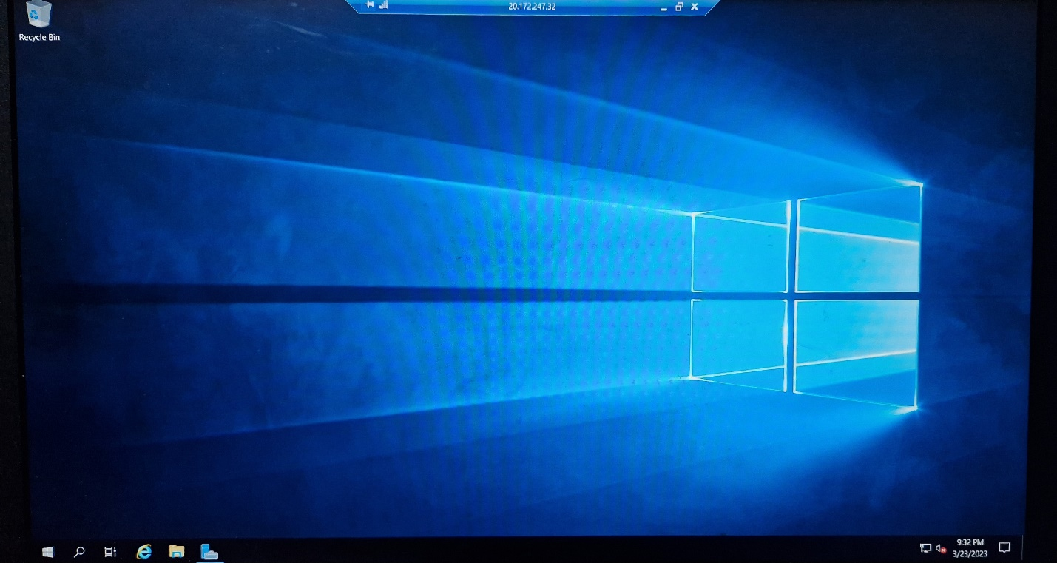

Then we open up the Windows PowerShell as admin and run the following command to test connectivity to the **az104-05-vm1:**

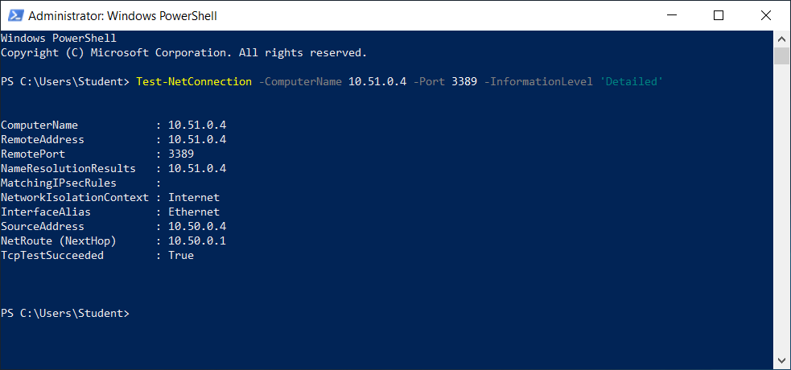

And also test connectivity to the **az104-05-vm2:**

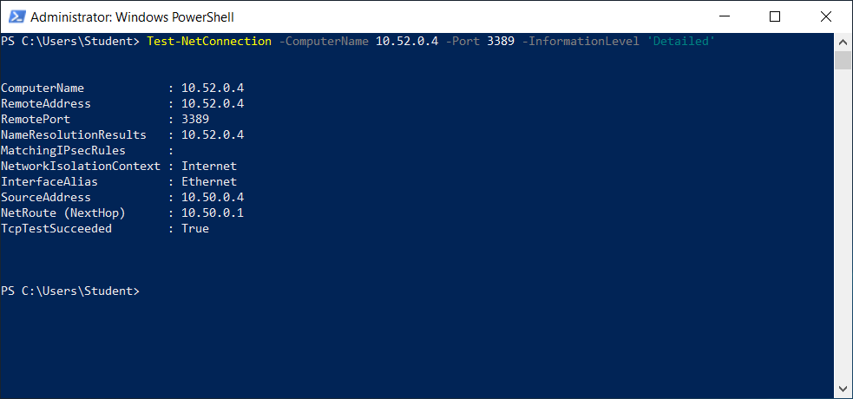

Both connections were successful.

Next up, we do the same **RDP connection to az104-05-vm1, start the PowerShell as admin and test the connectivity to az104-05-vm2 (same command as above):**

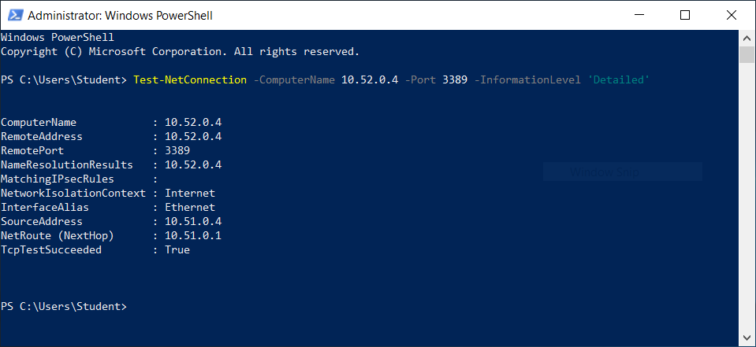

**Connection was successful.**